8.54: Solving Eq. (8.34) for 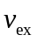and taking the magnitude to find the exhaust speed,
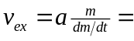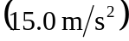 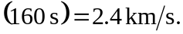 In this form, the quantity 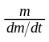is approximated by 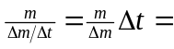160 s.

